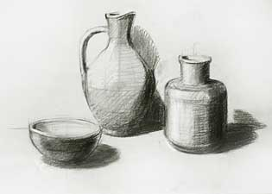
If I Was a Still Life
A still life is a work of art depicting mostly inanimate subject matters, typically commonplace objects which may be either natural (food, flowers, plants, rocks, or shells) or man-made (drinking glasses, books, vases, jewelry, coins, and so on). With origins dating from ancient Greek and Roman arts, still life paintings give the artist more leeway in the arrangement of design elements within a composition than paintings of other types of subjects such as landscape or portraiture.

Name: ___________________

Class period: ______________

Date: ___________________

Assignment: Create a still life drawing using items that represent your personal interests and experiences.

Directions:

- Create a composition using a minimum of three items (items should be three dimensional.) These items should relate to you personal interests and experiences. Include items that are different sizes, shapes, and details, to help create variety and visual interest.

- Make sure the proportions are accurate and that there is a likeness to the original objects.

- Use shading to add volume and depth to the image. Make sure the direction of the light source is used consistently.

- The drawing is scaled appropriately to the paper. ( No miniature drawings)

- Use either black paper and white color pencils or white paper and black color pencils to create your drawing. Regular graphite pencils can be used to sketch out initial shapes and the spatial composition of the still life.

- Keep in mind the principles of design as you draw:
(Rhythm, Perspective, Variety, Balance, Unity, Movement, Emphasis, Contrast)

- The finished product must be neatly completed and not “crumpled, dirty, scribbled, or rushed.”

- This project must be turned in on time. If it is more than two days late the grade is subject to be reduced by 50 %

- Class time must be used efficiently and you must demonstrate positive classroom behavior and a good work ethic.

Due Date ____________________ Maximum Points Possible ___________

