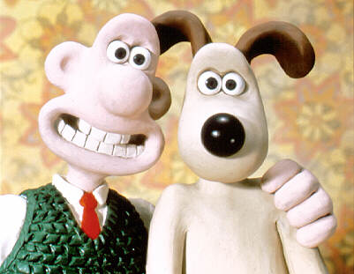
Quiz Review:

Use your claymation notes to fill in the blanks.

- The kids show Gumby was created by ______________________

- Ray _______________________ spent ________________ months creating a claymation scene for the movie Jason and the Argonauts.

- The creator of the popular TV commercial characters the _______________________ raisins was __________________________________

- The creator of Wallace and ____________________ is _____________________________

- Stop motion animation:
Objects are moved in _________________increments between individually photographed frames, creating the illusion of ______________________ when the series of frames are played as a __________________sequence.

- Plasticine: A type of __________, it is a putty-like modeling material. Plasticine is used extensively for __________________________, but also as a ______________ medium for more formal or permanent structures.

- Armature: A ___________________ around which a __________________ is built.

