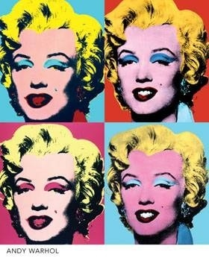
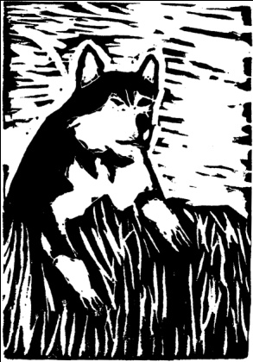
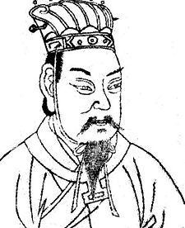
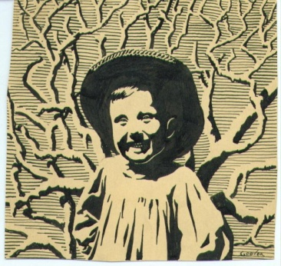

Printmaking

Name: ___________________

Class period: ______________

Date: ___________________

Assignment: Explore the art and medium of printmaking, and the importance of positive and negative space in the creation of a composition. To do this, students will use Styrofoam plates to create a printed series of an image of their choosing.

Directions:

- On rough draft or tracing paper, create a detailed example of the image you want to transfer to your printing plate. This image should be drawn from a reference image of either a person or nature. NO WORDS or NUMBERS can be used in your image.

- Once your rough draft is completed, transfer the image to the Styrofoam plate by tracing your drawings lines.

- Make one test print and a final edition where your image is used multiple times in the style of Andy Warhol. These two pieces will be turned into the teacher.

- You must show an effort to include details that help develop a strong relationship between positive and negative space ( different line widths and styles, crosshatching, light areas vs. dark areas)

- Keep in mind the principles of design as you create the composition of your post card.
(Rhythm, Perspective, Variety, Balance, Unity, Movement, Emphasis, Contrast)

- The finished product must be neatly completed and not “crumpled, dirty, splattered, smudged with ink or rushed.”

- This project must be turned in on time. If it is more than two days late the grade will be reduced by 50%

- Class time must be used efficiently and you must demonstrate positive classroom behavior and a good work ethic.

Due Date ____________________ Maximum Points Possible ___________

