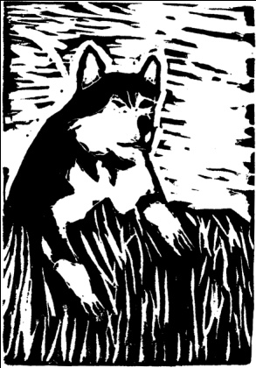
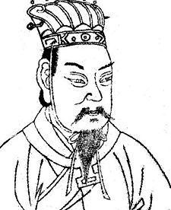
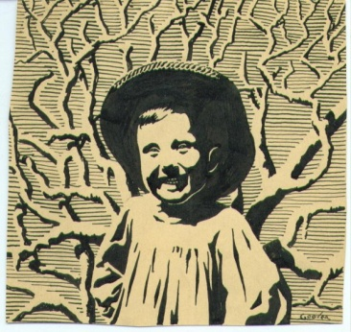

Printmaking
Project Evaluation:

Name: ______________________ Class Hour ______________________

 | Zero points | Partial points | Full points
Class time was used properly and the student displayed positive classroom behavior, effort, and participation. (+10)
One test print that is neatly completed (no ink smudges, finger prints, nice clean visible image) (+5)
A neatly completed Final edition print where the image is used in multiples ( a minimum of three times unless otherwise approved)(+5)
Self evaluation completed. (+5)
All elements and requirements are met. This includes detailed elements, a variety of different line weights and styles, correct use of positive /negative space, no letters or numbers. (+15)

Total Points: ______/ 40

