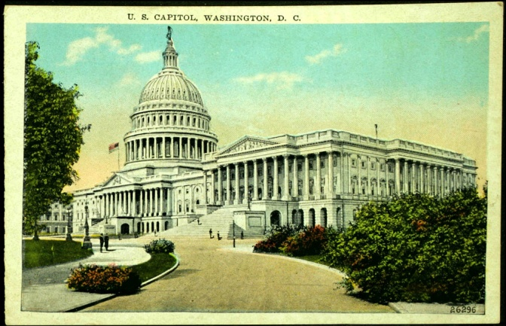
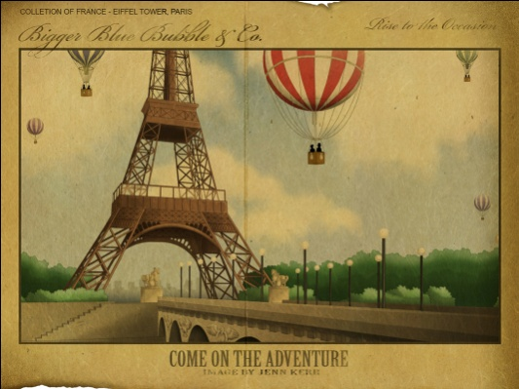

Name: ___________________

Class period: ______________

Date: ___________________

Assignment: Explore landscape painting and watercolor painting by creating a postcard that depicts your dream vacation destination.

Directions:

- On postcard scale paper, paint a detailed landscape of your dream vacation destination. On the back use research or personal memories to pretend to send a message about your trip/experience.

- You may use printed images as a reference for your drawing but you may not directly copy or trace. It is suggested that you sketch out your landscape in pencil before you paint.

- The post card must be completely painted using watercolor paints. Each painting must use at least one special effect technique to enhance the painting. (white crayon, rubber cement ,lemon juice, water color pencils, salt )

- You must show an effort to include details that help to identify the location depicted on your postcard. (palm trees, monuments, people, animals, signs, postmark for the back, stamp on the back)

- Keep in mind the principles of design as you create the composition of your post card.
(Rhythm, Perspective, Variety, Balance, Unity, Movement, Emphasis, Contrast)

- The finished product must be neatly completed and not “crumpled, dirty, splattered, or rushed.”

- This project must be turned in on time. If it is more than two days late the grade will be reduced by 50%

- Class time must be used efficiently and you must demonstrate positive classroom behavior and a good work ethic.

Due Date ____________________ Maximum Points Possible ___________

