A short history of Claymation

Art Clokey: During 1956-1963 he brings attention to claymation through the kids show “Gumby”. 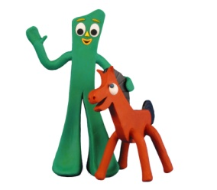

Ray Harryhausen: Takes four and a half months to create “Jason and the Argonauts” in 1963.
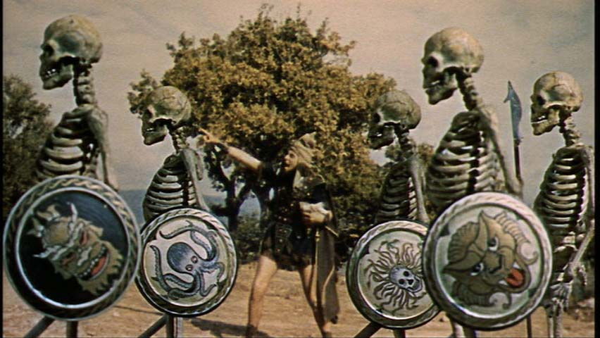

Will Vinton: He creates the “California Raisins” as part of a commercial that would be later expanded into a television special.
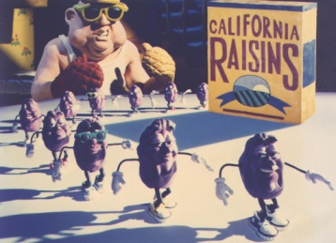

Nick Park: Wins an Academy Award for creating “Creature Comforts” a movie that has zoo animals narrated by pre- recorded human interviews.

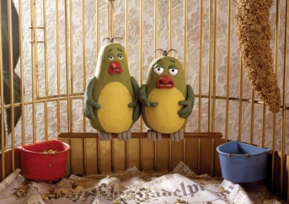

Nick Park: Also wins an Oscar for “Wallace and Gromit: The Wrong Trousers.” 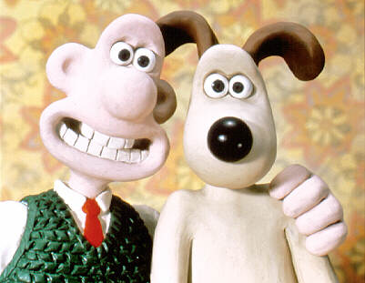

Claymation Vocabulary

Name:

Hour:

- Stop motion animation:
Objects are moved in small increments between individually photographed frames, creating the illusion of movement when the series of frames are played as a continuous sequence.

In your own words:

- Plasticine: A type of clay, it is a putty-like modeling material. Plasticine is used extensively for children's play, but also as a modeling medium for more formal or permanent structures.
In your own words:

- Armature: A framework around which a sculpture is built.
In your own words:

