Name: ___________________________ Hour: __________________

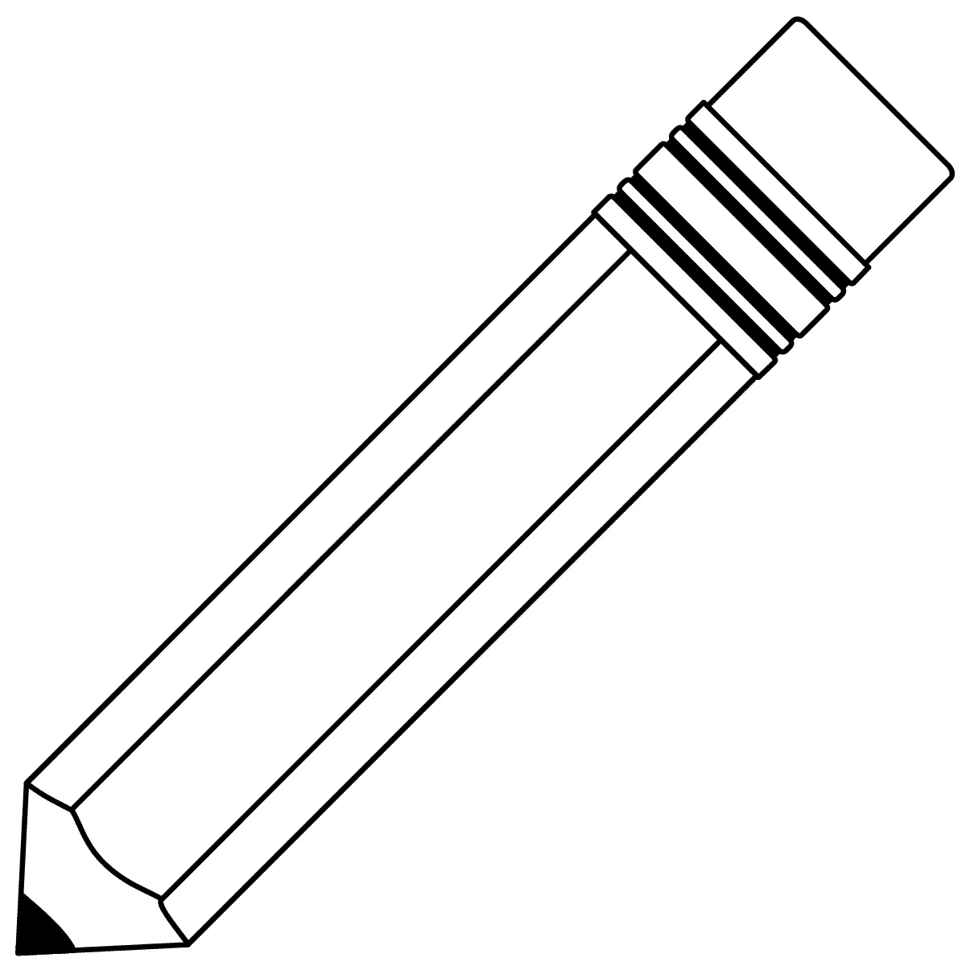
Design Unit
“I Can Statements”
I Can … | Section of project, classroom notes, or worksheets that provided information on this standard. | Nope! | On My Way!! | Almost There | Got It!!
Discuss the basic aspects of a career in graphic design.
Discuss and understand how a graphic designer’s decisions are influenced by outside forces like the consumers.
Identify and use the elements and principles of art to create a finished artwork.
Compose different shapes and forms into unique examples of graphic design.

Recognize iconic graphic designs and their relationship to our choices as a consumer.
Follow directions in art class to become successful in making a particular work according to the concepts given for the project.
Use different drawing media to illustrate forms and shapes.

