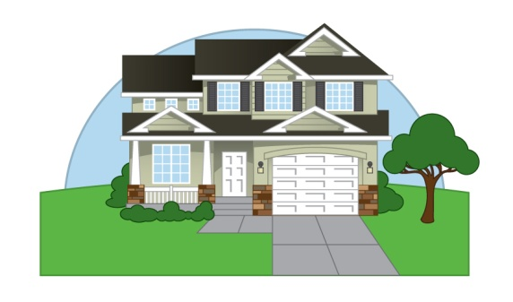

Project Evaluation:

Name: ______________________ Class Hour ______________________

 | Zero points | Partial points | Full points
Class time was used properly and the student displayed positive classroom behavior, effort, and participation. (+10)
exterior drawing that is neatly completed, and is more than the basic box and triangle design (+5)
Detailed interior drawing that is neatly completed and labeled(+5)
Self evaluation completed. (+5)
All elements and requirements are met. This includes detailed elements, the majority of the exterior shaded, correct use of light source, and ruler straight lines (+15)

Total Points: ______/ 40

